**DOKUZ EYLUL UNIVERSITY**

**ENGINEERING FACULTY**

**DEPARTMENT OF COMPUTER ENGINEERING**

**CME1251 PROJECT BASED LEARNING – I**

**PROGRESS REPORT**

**PROJECT – I**

**Archery Game**

**by**

**ISLAM RAMAZANOV**

**YASAMIN VALISHARIATPANAHI**

**NİYAZİ EMRE AKBAŞ**

**KEREM KALINTAŞ**

**Lecturers**

**TANZER ONURGİL  
Dr. Atakan KUBİLAY**

**21.10.2022**

# CHAPTER ONE

PROGRESS SUMMARY

## Work Done

ISLAM RAMAZANOV

In the beginning I’ve faced a problem with c# syntaxes, but I took a courses and found out, how to create a random variables, conditions e.t.c. So I started to write the conditions in our program and adding some details in a gaming process.

YASAMIN VALISHARIATPANAHI

At first we started to write the algorithm and draw the flowchart of it then we started to code. In the mean while we fixed our flowchart diagram. After practicing C# in laboratory class, it really helped me to write the second round of the code.

NİYAZİ EMRE AKBAŞ

I gathered some information about the flowchart and I did draft of it and we discuss about how can we improve our flowchart with my project friends and I compare my codes with agreed codes by my project friends and some debugging with them.

KEREM KALINTAŞ

I mainly wrote code in this project. I read the game project paper carefully and maked sure that we wrote our code according to the rules. I wrote the code for printing the grid to console, round one of the game and getting the inputs from the user.

## Work in Progress

ISLAM RAMAZANOV

I was trying to handle with coordinate system cause of the reason that I was not able to show the output of the A,B and C locations on the field, but then I realized that the problem was in my OS, I’ve changed OS and got appropriate result.

YASAMIN VALISHARIATPANAHI

We are controling part of the code and the flowchart, if there is a mistake we will fix it together the debugging part of our project.

NİYAZİ EMRE AKBAŞ

Doing debugging and check if there is any problems. Writing more comments and making the code more readable.

KEREM KALINTAŞ

Fixing the bugs and logic errors in the game.

## Work to Be Done

ISLAM RAMAZANOV

We are just checking, controlling, verifying, debugging and adding some more details in to the project.

YASAMIN VALISHARIATPANAHI

We can add additionals into the game; like the user can choose between sets or even chose the avatar of the player instead of just the character A, or also add a control if the character are in the same place, if they are they should be rearrange.

NİYAZİ EMRE AKBAŞ

We going to do some good looking things to our flowchart and game. And we going to conclude all errors and bugs.

KEREM KALINTAŞ

We need to check users inputs to make sure they are just numbers. And we need to print a error message and close the game if user gives unvalid input.

# CHAPTER TWO

algorıthms and solutıon strategıes

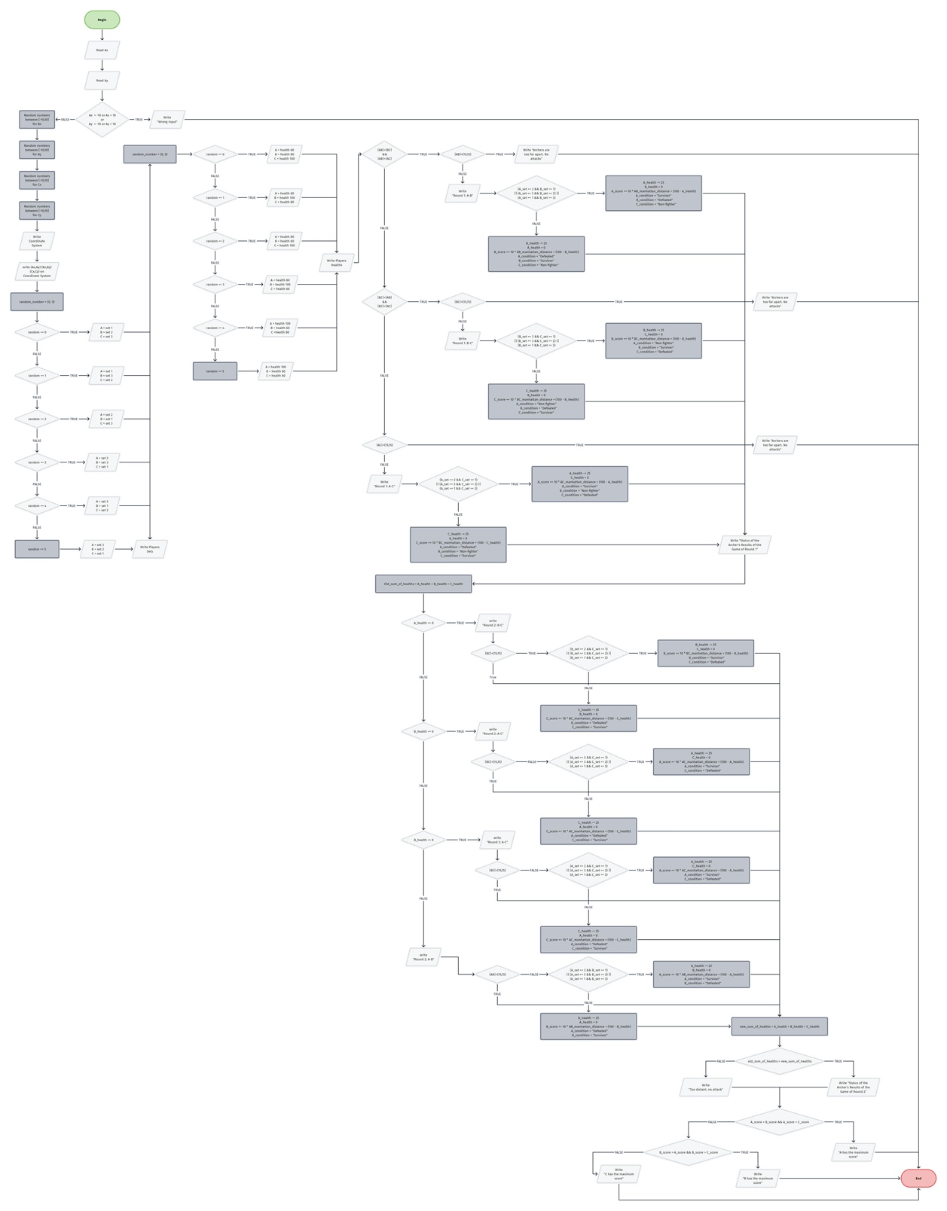

ISLAM RAMAZANOV

Honestly writing flowcharts was a little bit hard at the beginning, and for me it easier to write the code and use a comments to write a program, but I have to admit that it was a good experience for me and I learned a lot. My solution strategy was quite easy —> I just took a course and was learning till the moment when I will be able to write the project without any problems. And it was a good strategy.

YASAMIN VALISHARIATPANAHI

Writing the flowchart was a bit challenging because of the usage of too many decision symbols; one mistake and you have to change all of the writen conditions. It was really helpful and nice to have teammates to check, if i have made a mistakes by typing inncorrectly or in the drawing the flowchart. That really helped me to undrestand the flowchart much better by understanding my mistake so i don’t repeat them again. In some parts of the flowchart writing the code made it better to realize how to draw the flowchart without it we kind of felt a bit lost and it seemed really hard to draw.

NİYAZİ EMRE AKBAŞ

This was my first C# experience so firstly I learned beginning of C# Then i made a first draft of my code. Later i saw my project friends went well and I learned them too much (randomly giving set situation, if and else operators etc.) and I added to my code them. Lastly I finish my code and gave some opinion to others and we finished our project.

KEREM KALINTAŞ

I used squares of the actual distance in round 1 and round 2 to not use square root. And compared those distances with square of the max arrow travel distance. I calculated manhattan distance between players by getting the absolute value of difference between coordinates.

# CHAPTER THREE

PROBLEMS ENCOUNTERED

ISLAM RAMAZANOV

I was working as a data analyst in my country and I was using python as my programming language, so it was easier for me to understand the principles of the C**#.** But anyway I had a problem with the logic of this language cause it was so unlogic for me after using python, but when I’ve learnt a little bit I fill a little interest about learning it. It was not my first group project but it was a first these kind of experience.

YASAMIN VALISHARIATPANAHI

Learning the programming language of C# at first felt a bit hard to code. But after I learned it in the Algorithm and Programming class and have practices at the labratuary of the class, it felt better even a little bit easy. Maybe knowing other programming languages make it like it. But I am still learning C#.

As long as I remember I worked really good in a teamwork projects. When i met my teammates it felt a bit stresful because I didn’t know them, but after I began to; I felt much better even I learnd a bit C# from one of our teammates and made new friends.

NİYAZİ EMRE AKBAŞ

After the finishing game I found a problem if set 1 and set 3 fighting with each other set 3 winning fight because 3 numerically greather than 1 so I decide I shouldnt compare with numbers then I wrote situations one by one and solved the problem.

KEREM KALINTAŞ

I never worked with a team before. That was the most challenging part for me. But implementing the logic for deciding who wins the fight in a round was a challenge too. I wrote it wrong in the begining and corrected it afterwards.